**PRE-LAB REPORT**

**Experiment No :** 07

**Name of The Experiment :** Experimental Study of op-amp-based integrator and differentiator.

1. **Integrator:**

**Fig – 01 :** Integrator circuit and its input -output result

1. **Differentiator:**

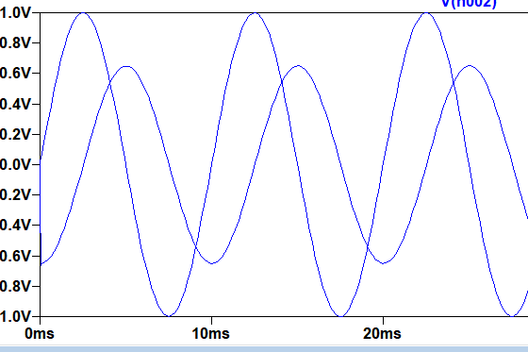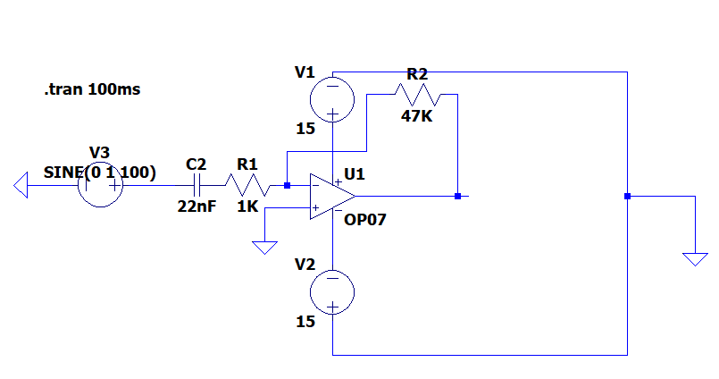

**Fig – 02 :** Differentiator circuit and its input and output result